# Durable Furnitures

Alfonso

## Metamorphic Table Lamp

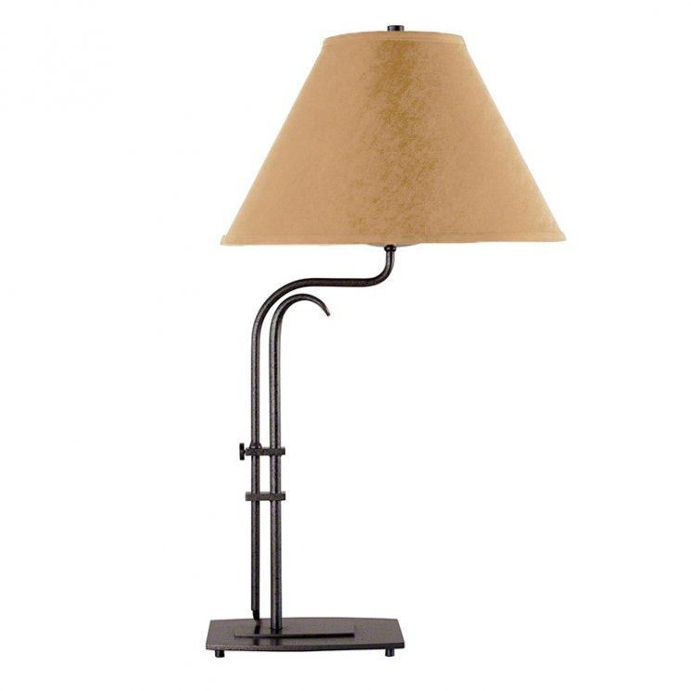

Contemporary style with a slight Asian influence best describes Hubbardton Forge's Metra Metamorphic Table Lamp. Whether you're looking for that beautiful accent piece for your living room end table or a useful reading lamp for your bedside nightstand, this lamp will be just the trick.